7.AIM:-To implement UML diagrams for CREDIT CARD PROCESSING SYSTEM…

1.ACTIVITY DIAGRAM:-

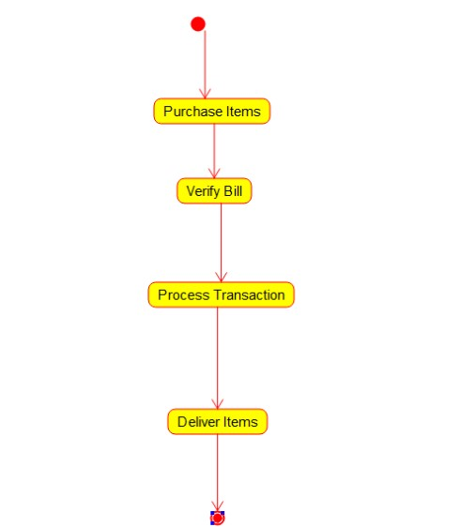

2.CLASS DIAGRAM:-

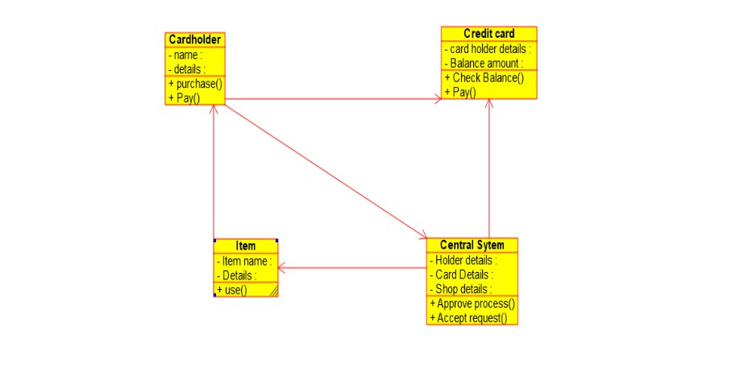

3.COMPONENT DIAGRAM:-

